PHASE 5
Project Development
Actual Source Code
Key implementation snippets from the AI StudyBuddy backend are shown below.
Topic Schema
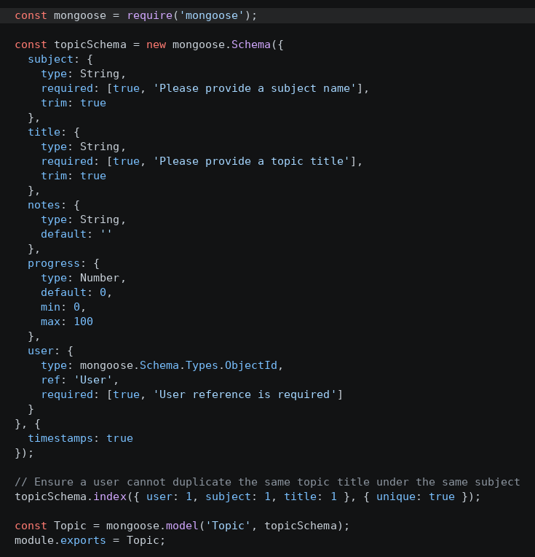
Fig 5.1 – Mongoose Topic schema definition

User Schema

Fig 5.2 – Mongoose User schema definition
Database Connection
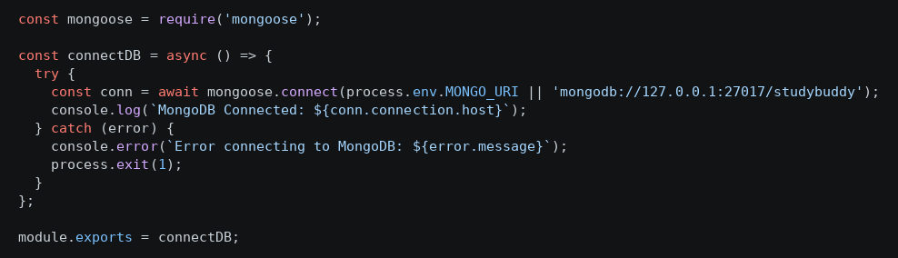
Fig 5.3 – MongoDB connection module using Mongoose

Application Entry Point (index.js)

Fig 5.4 – index.js – Express server initialization and route registration
Database Implementation
MongoDB was used as the NoSQL document database, with Mongoose ODM enforcing schema validation. Two primary collections were implemented:
- Users collection – stores name, email (unique), hashed password, and role, used for authentication and authorization.
- Topics collection – stores subject, title, notes, progress, creation timestamp, and a foreign-key reference to the owning user, supporting the One-to-Many relationship between users and their study topics.
Modules Developed
- Authentication Module – registration, login, JWT issuance, bcrypt password hashing.
- Topic Module – full CRUD for subjects and study topics, scoped to the authenticated user.
- Notes Module – stores and retrieves study notes and progress details for each topic.
- AI Study Aid Module – integrates Google Gemini AI to generate natural-language summaries, practice questions, and personalized revision recommendations.
- Admin Module – user account management and API/service health monitoring.
- Middleware – authentication guard, role-based access control, request sanitization, centralized error handling.
Important Implementation Details
- Passwords are never stored in plain text – bcrypt.js hashes them before persistence.
- JWT tokens are issued on login and validated on every protected route via middleware.
- The system includes a resilient fallback mode so AI endpoints remain operational even without external API keys.
- Centralized error-handling middleware returns consistent JSON error responses across the API.
- Request sanitization prevents XSS and NoSQL injection through parameter cleansing.

